**Graphic Era Hill University, Haldwani BCA Project Report**

**For**

## Smart Surveillance Using Computer Vision

**Submitted to Graphic Era Hill University, Haldwani for the partial fulfillment of the requirement for the Award of degree for**

BACHELOR’S IN COMPUTER APPLICATIONS



**Submitted by :- Under the Guidance of :-**

Deepankar Sharma Ms :-RICHA PANDEY

Pawan Chandra Faculty of GEHU, Haldwani

Amit Sati

## DECLARATION

I hereby declare that the work which is being present in this project report **“Smart Surveillance Using Computer Vision”,** in partial fulfilment of the requirement for the Award of the degree of **BACHELOR’S IN COMPUTER APPLICATION**, submitted at **GRAPHIC ERA HILL UNIVERSITY, HALDWANI**

is an authentic work done by me during period from 1st March 2023 to 1st June 2023.

Project Guide: Signature of the Student:

Deepankar ( 2092016)

Pawan (20920)

Ms. Richa pandey Amit (2092005)

Faculty of GEHU Graphic Era Hill University, Haldwani

## BONAFIDE CERTIFICATE

Certified that this project report **Smart Surveillance Using Computer Vision** is the bonafide work of **Deepankar Sharma , Pawan Chandra and** **Amit Sati** who carried out the project work under my supervision.

Name – Ms Richa Pandey

HEAD OF THE DEPARTMENT SUPERVISOR

Computer Application Graphic Era Hill University Haldwani

## ACKNOWLEDGEMENTS

I would like to extend our thanks and appreciation to all those who have assisted us either directly or indirectly and participated in the success of this project. I would like to thank my guide Ms.Richa Pandey for his constant support in the making of the project. As a part of University Curriculum, a 6th semester project is a paramount importance to an BCA student’s curriculum and being our native effort into this project undertook by us, we faced a lot of impediments on our way to the completion of this project but constant guidance and able support of concerned software engineer members lend us a great help in successful completion of the project. I am thankful to all staff members of Graphic Era Hill University who helped me whenever required, during my project. Even though I expressed my gratitude to every person who helped me in reaching this stage, there might be a few, who’d been left out, who helped me without my knowledge. I would like to thank all of them. Last but not least, to all my friends and fellow students for giving me suggestions and helping us in debugging the code errors and above all the faculty of my Department of Computer Science Graphic Era Hill University who have always provided their guidance, support and well wishes.

Deepankar Sharma

Pawan Chandra

Amit Sati

## ABSTRACT

The development of a smart surveillance system has become an increasingly important topic in recent years, with the aim of providing more accurate and efficient monitoring of people and objects in real-time. This project focuses on developing a smart surveillance system that can be appended to existing surveillance systems, providing them with advanced features such as motion detection using contours and real-time people tracking using YOLOv3.

The proposed system uses computer vision algorithms to analyze the video feed from existing surveillance cameras, identifying areas of motion and tracking the movement of objects within those areas. To detect and track people specifically, the system uses object detection algorithms like YOLOv3, which is a deep learning-based model that can accurately detect and track objects in real-time.

To build this system, expertise in computer vision, machine learning, and software development is required. Additionally, access to large datasets of labeled video footage is necessary for training and testing the deep learning models, and powerful hardware is required to process the video feed in real-time.

The system has the potential to significantly improve surveillance systems by providing more accurate and efficient monitoring of people and objects in real-time. The motion detection feature using contours can reduce false alarms and improve the accuracy of the system, while the real-time people tracking feature using YOLOv3 can enable security personnel to monitor and track people of interest more effectively.

Overall, the proposed smart surveillance system has the potential to provide a significant improvement to existing surveillance systems, providing more accurate and efficient monitoring of people and objects in real-time, ultimately enhancing the security and safety of the monitored areas.

## TABLE OF CONTENT

* **ACKNOWLEDGEMENTS**

## ABSTRACT

* **INTRODUCTION**

## SYSTEM REQUIREMENT ANALYSIS

* **SYSTEM DESIGN**

## HARDWARE AND SOFTWARE REQUIREMENT

* **LIMITATION OF THE ONLINE SHOPPING WEBSITE**

## APPENDICES

* **CONCLUSION**

## BIBLIOGRAPHY

**SMART SURVEILLANCE**

## INTRODUCTION

The development of a smart surveillance system with advanced features such as motion detection using contours and real-time people tracking using YOLOv3 is presented in this project. The system uses computer vision algorithms to analyze the video feed from existing surveillance cameras, identifying areas of motion and tracking the movement of objects within those areas. To detect and track people specifically, the system uses object detection algorithms like YOLOv3. The project requires expertise in computer vision, machine learning, and software development, as well as access to large datasets of labeled video footage and powerful hardware to process the video feed in real-time. The system has the potential to improve surveillance systems by providing more accurate and efficient monitoring of people and objects in real-time.

## PROJECT OVERVIEW:

The aim of this project is to develop a smart surveillance system that can be integrated with existing surveillance systems to provide advanced features like motion detection using contours and real-time people tracking using YOLOv3. The system uses computer vision algorithms to analyze the video feed from surveillance cameras and identify areas of motion, while object detection algorithms like YOLOv3 are used to detect and track people in real-time.

The project requires expertise in computer vision, machine learning, and software development. Large datasets of labeled video footage are needed to train and test the object detection and motion tracking algorithms. Powerful hardware is also required to process the video feed in real-time.

The smart surveillance system has several potential benefits, such as reducing false alarms and improving the accuracy of surveillance systems. It can also enable security personnel to monitor and track people of interest more effectively.

The project will involve conducting a system requirement analysis, system design, hardware and software requirements, and limitations of the smart surveillance system. Additionally, the project will require the development of a prototype smart surveillance system that can be demonstrated using sample video footage. The final outcome of this project is a functional smart surveillance system that can be integrated with existing surveillance systems, providing advanced features for real-time monitoring and tracking of people and objects.

* 1. **PROJECT SCOPE:**

The smart surveillance system developed in this project has a wide range of potential application areas, including:

Security and Surveillance: The system can be used to improve the effectiveness of security and surveillance operations in various locations, such as airports, malls, stadiums, and public transportation systems.

Traffic Monitoring: The system can be used to monitor traffic flow and detect any accidents or incidents that may occur on highways, streets, and other transportation networks.

Industrial Automation: The system can be used in industrial settings, such as factories and warehouses, to monitor production lines, detect faults, and ensure worker safety.

Healthcare: The system can be used in healthcare facilities, such as hospitals and nursing homes, to monitor patient movement and ensure their safety.

Retail Analytics: The system can be used in retail stores to analyze customer traffic and behavior, detect shoplifting, and improve store layout and product placement.

Smart Cities: The system can be used to improve the safety and security of public spaces, such as parks and streets, and monitor urban infrastructure, such as bridges and buildings.

In summary, the smart surveillance system developed in this project has a broad range of potential applications, from improving security and surveillance operations to enhancing traffic monitoring, industrial automation, healthcare, retail analytics, and smart city initiatives. The system has the potential to provide real-time tracking and analysis of people and objects, improving the accuracy and efficiency of monitoring operations in various settings.

## System Requirement Analysis

* 1. **Information Gathering**

The Information Gathering process was an essential step in the development of the Smart Surveillance System. This process involved identifying the needs of stakeholders, understanding use cases, and determining the technical requirements for the system.

Stakeholder Identification

The first step in the Information Gathering process was to identify the stakeholders of the Smart Surveillance System. The stakeholders included:

End-users of the system such as security personnel or law enforcement officials

Owners or operators of the surveillance systems that were to be integrated with the Smart Surveillance System

Developers or designers of the Smart Surveillance System

Regulators or legal authorities responsible for overseeing surveillance operations

Use Case Analysis

Once the stakeholders were identified, the next step was to analyze the use cases of the Smart Surveillance System. Use cases included:

Real-time monitoring of areas for security purposes

Investigation of criminal activity using surveillance footage

Traffic management and monitoring in public areas

Industrial monitoring of machinery and equipment

Environmental monitoring of wildlife or natural resources

Technical Requirements

The final step in the Information Gathering process was to determine the technical requirements for the Smart Surveillance System. These requirements included:

Compatibility with different types of cameras and video management systems

High accuracy and efficiency in motion detection and people tracking

Low latency and high throughput for real-time monitoring and tracking

Scalability for use in large-scale surveillance operations

Security features to protect the privacy of monitored individuals

By completing the Information Gathering process, the requirements for the Smart Surveillance System were defined and documented in the Software Requirements Specification (SRS). This ensured that the system was developed to meet the needs of the stakeholders and was of high quality.

* 1. **System Feasibility**

The system feasibility can be divided into the following sections:

Technical Feasibility Study

The Project can be developed simply by using two platforms i.e. JAVA and Tomcat as frontend and MySQL Server as back-end. All the functions of a Online Shopping System can be implemented in the new system. Hence it is technically feasible.

Economic Feasibility study

This feasibility study present tangible and intangible benefits from the project by comparing the development and operational cost. The technique of cost benefit analysis is often used as a basis for assessing economic feasibility. This system needs some more initial investment than the existing system, but it can be justifiable that it will improve quality of service.

Thus feasibility study should centre along the following points:

* Improvement resulting over the existing method in terms of accuracy, timeliness.
* Cost comparison
* Estimate on the life expectancy of the hardware.
* Overall objective Our project is economically feasible.

It does not require much cost to be involved in the overall process. The overall objective is in easing out the recruitment processes.

Time Feasibility Study

it has been more probable (as per the requirements and functions specifications of the system) that the project can be completed within the given timeframe, it is considered that the undertaking this project is feasible in the context of time.

Operational Feasibility Study

If the system meets the requirements of the customers and the administrator we can say that the system is operationally feasible. The proposed system will be beneficial only if it can be turned into a system which will meet the requirements of the store when it is developed and installed and there is sufficient support from the users. The proposed system will provide a better market for different dealers.

Social Feasibility Study

This analysis involves how it will work when it is installed and the assessment of political and managerial environment in which it is implemented. People are inherently resistant to change and computers have been known to facilitate change. The new proposed system is very much useful to the users and Social feasibility is determination of whether a proposed project will be acceptable to people or not, So this project is totally Social and Feasible.

## SYSTEM DESIGN

System design is the solution for the creation of a new system. This phase focuses on the detailed implementation of the feasible system. It emphasis on translating design. Specifications to performance specification. System design has two phases of development

* + Logical design
  + Physical design

During logical design phase the analyst describes inputs (sources), output s(destinations), databases (data sores) and procedures (data flows) all in a format that meets the user requirements. The analyst also specifies the needs of the user at a level that virtually determines the information flow in and out of the system and the data resources. Here the logical design is done through data flow diagrams and database design. The physical design is followed by physical design or coding. Physical design produces the working system by defining the design specifications, which specify exactly what the candidate system must do. The programmers write the necessary programs that accept input from the user, perform necessary processing on accepted data and produce the required report on a hard copy or display it on the screen.

* 1. **INPUT AND OUTPUT DESIGN INPUT DESIGN**:

Input design is the link that ties the information system into the world of its users. The input design involves determining the inputs, validating the data, minimizing the data entry and provides a multi- user facility. Inaccurate inputs are the most common cause of errors in data processing. Errors entered by the data entry operators can be controlled by input design. The user-originated inputs are converted to a computer based format in the input design. Input data are collected and organized into groups of similar data. Once identified, the appropriate input media are selected for processing. All the input data are validated and if any data violates any conditions, the user is warned by a message. If the data satisfies

all the conditions, it is transferred to the appropriate tables in the database. In this project the student details are to be entered at the time of registration. A page is designed for this purpose which is user friendly and easy to use. The design is done such that users get appropriate messages when exceptions occur.

OUTPUT DESIGN:

Computer output is the most important and direct source of information to the user. Output design is a very important phase since the output needs to be in an efficient manner. Efficient and intelligible output design improves the system relationship with the user and helps in decision making. Allowing the user to view the sample screen is important because the user is the ultimate judge of the quality of output. The output module of this system is the selected notifications.

SYSTEM TOOLS

The various system tools that have been used in developing both the front end and the back end of the project are being discussed in this chapter.

FRONT END:

BACK END:

# FLOWCHART



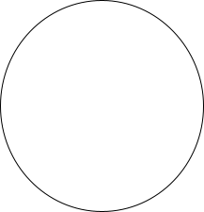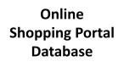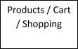

* 1. **DFD**

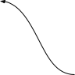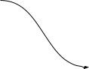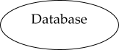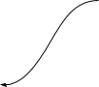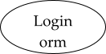

# (0 level DFD)

**For Registration**

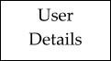

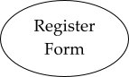

Username Exists

Success

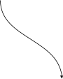

# For Login

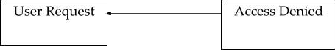

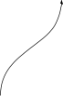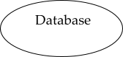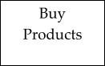

Not Authenticate

Authenticate

**For Buying Product:**

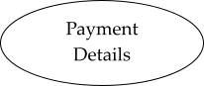

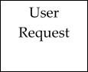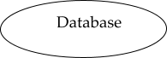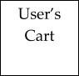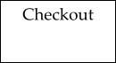

* 1. **E-R Diagram**

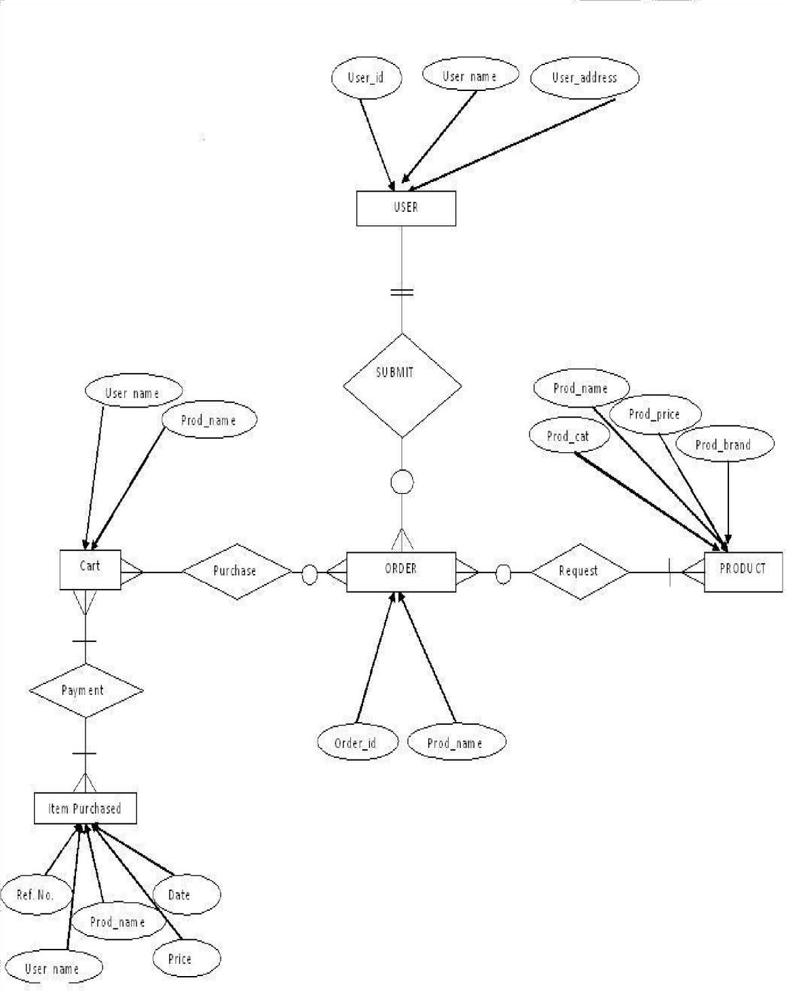

## 4 Hardware And Software Requirement

Hardware Requirement

* PC with 250 GB or more Hard disk.
* PC with 2 GB RAM.
* PC with Pentium or higher.

Software Requirement

* Operating System - Windows XP / Windows, Android
* Automation Tool – Apache maven
* Server - Tomcat

## Limitation of the Online shopping website

First, the physical and photos of the gap is too big

Net purchase only is seen pictures of goods, to really get your hands, you will feel and the objects are not the same as. This is not in the mall to buy the rest assured.

Second, do not try

online shopping is just to see pictures and articles on the simple introduction, like clothes or shoes and the like, you can directly see the suitable for you, and if in the mall to buy, you can try it on, his body, immediately buy, not so much to consider, however, online shopping is more trouble.

Third, online payment security

Can be peeping, stolen passwords. Online shopping is most worried about is that he needs to use a bank account, some friends of the computer there is pilfer date trojan, can cause some serious account loss occurs, so everyone in the shopping time try not to choose the Internet cafes and other public places, your computer must also ensure the antivirus software can be installed network transaction.

Fourth, good faith question

Is the owner 's credit, if encountered poor service quality of the owner, asked a few questions appear impatient. Also in the online shopping appearance deceived happens.

Fifth, the speed of delivery problem

Online purchases, but also after the distribution of the link, the fast one or two days, would slow to a week or more, sometimes, there are still some problems in the process of distribution, and, if the goods are not satisfied with, and through distribution link, change the items, so much trouble; while in the mall, see you want, just get, if not satisfied, instead of directly.

Sixth, return the problem of inconvenient

Although the reality of shopping return requires a complex procedure, and even on the product to be protected, but the net return is relatively more difficult. Even proposed various unreasonable request refused to return and buck.

## Appendices code

Index.jsp

<%@page import="com.website.onlineshopping.helper.Helper"%>

<%@page import="com.website.onlineshopping.entities.Category"%>

<%@page import="com.website.onlineshopping.dao.CategoryDao"%>

<%@page import="java.util.List"%>

<%@page import="com.website.onlineshopping.entities.Product"%>

<%@page import="com.website.onlineshopping.dao.ProductDao"%>

<%@page import="com.website.onlineshopping.helper.FactoryProvider"%>

<%@page contentType="text/html" pageEncoding="UTF-8"%>

<!DOCTYPE html>

<html>

<head>

<meta http-equiv="Content-Type" content="text/html; charset=UTF-8">

<title>Online Shopping</title>

<%@include file="components/common_css_js.jsp" %>

</head>

<body>

<%@include file="components/navbar.jsp" %>

<div class="container-fluid">

<div class="row mt-2 ">

<%

String cat =request.getParameter("category");

ProductDao dao = new ProductDao(FactoryProvider.getFactory()); List<Product> list = null;

if(cat==null || cat.trim().equals("all"))

{

list = dao.getAllProducts();

}else {

int cid = Integer.parseInt(cat.trim()); list = dao.getAllProductsById(cid);

}

CategoryDao cdao = new CategoryDao(FactoryProvider.getFactory()); List<Category> clist = cdao.getCategories();

%>

<!-- show categories-->

<div class="col-md-2">

<div class="list-group mt-4">

<a href="index.jsp?category=all" class="list-group-item list-group-item-action

active">

All Products

</a>

<%

for(Category c : clist){

%>

<a href="index.jsp?category=<%= c.getCategoryId() %> " class="list-group-item list-group-item-action"><%=c.getCategoryTitle() %></a>

<% }

if(list.size()==0){

out.println("<h3>No item in this category</h3>");

}

%>

</div>

</div>

<!--show products-->

<div class="col-md-10">

<div class="row mt-4 ">

<div class="col-md-12 ">

<div class="card-columns product-card ">

<%

for(Product p:list){

%>

<div class="card">

<div class=" text-center">

<img class="card-img-top mt-2" style="max-height: 200px; max-width: 200px; width: auto; " src="img/products/<%=p.getpPhoto() %>" alt="Card image cap"/>

</div>

<div class="card-body">

<h5 class="card-title"> <%= p.getpName() %></h5>

<p class="card-text">

<a href="#" style="color:brown"><%= Helper.get10Words(p.getpDesc()) %></a>

</p>

</div>

<div class="card-footer text-center">

<h6> Product Id : <%= p.getpId() %></h6>

<button class="btn custom-bg text-white" onclick="add_to_cart(<%=p.getpId() %> , '<%=p.getpName() %>', <%=p.getpPrice()

%>)">Add to Cart</button>

<button class="btn btn-outline-success"> &#8377;<%=p.getPriceAfterApplyingDiscount() %>/- <span class="text-secondary discount- label"> <strike>&#8377;<%= p.getpPrice() %></strike> <%= p.getpDiscount() %>% off</span></button>

</div>

</div>

<% } %>

</div>

</div>

</div>

</div>

</div>

</div>

<div>

<%@include file="components/footer.jsp" %>

</div>

<%@include file="components/common_modals.jsp" %>

</body>

</html>

* **admin.jsp**

<%@page import="com.website.onlineshopping.helper.Helper"%>

<%@page import="java.util.Map"%>

<%@page import="java.util.List"%>

<%@page import="com.website.onlineshopping.entities.Category"%>

<%@page import="com.website.onlineshopping.dao.CategoryDao"%>

<%@page import="com.website.onlineshopping.helper.FactoryProvider"%>

<%@page import="com.website.onlineshopping.entities.User"%>

<%

User user = (User) session.getAttribute("current-user"); if(user==null){

session.setAttribute("message","You are not logged in !!!"); response.sendRedirect("login.jsp");

return;

}else

{

if(user.getUserType().equals("normal")){ session.setAttribute("message","You are not admin !!!"); response.sendRedirect("login.jsp");

return;

}

}

%>

<%

CategoryDao cdao = new CategoryDao(FactoryProvider.getFactory()); List<Category> list = cdao.getCategories();

Map<String,Long> m = Helper.getCounts(FactoryProvider.getFactory());

%>

<%@page contentType="text/html" pageEncoding="UTF-8"%>

<!DOCTYPE html>

<html>

<head>

<meta http-equiv="Content-Type" content="text/html; charset=UTF-8">

<title>Admin Panel</title>

<%@include file="components/common_css_js.jsp" %>

</head>

<body>

<%@include file="components/navbar.jsp" %>

<div class="container admin">

<div class="container-fluid mt-3">

<%@include file="components/message.jsp" %>

</div>

<div class="row mt-3">

<div class="col-md-4">

<!--first call-->

<div class="card" >

<div class="card-body text-center">

<div class="container">

<img style="max-width: 125px;" class="img-fluid rounded-circle" src="img/team.png" alt="">

</div>

<h1><%= m.get("userCount")%></h1>

<h2 class="text-uppercase text-muted">Users</h2>

</div>

</div>

</div>

<div class="col-md-4">

<!--second call-->

<div class="card" >

<div class="card-body text-center">

<div class="container">

<img style="max-width: 125px;" class="img-fluid rounded-circle" src="img/list.png" alt="">

</div>

<h1><%=list.size() %></h1>

<h2 class="text-uppercase text-muted">Categories</h2>

</div>

</div>

</div>

<div class="col-md-4">

<!--third call-->

<div class="card" >

<div class="card-body text-center">

<div class="container">

<img style="max-width: 125px;" class="img-fluid rounded-circle" src="img/list.png" alt="">

</div>

<h1><%= m.get("productCount")%></h1>

<h2 class="text-uppercase text-muted">Products</h2>

</div>

</div>

</div>

</div>

<!--second row-->

<div class ="row mt-3">

<div class="col-md-4">

<div class="card" data-toggle="modal" data-target="#add-category-modal" >

<div class="card-body text-center">

<div class="container">

<img style="max-width: 125px;" class="img-fluid rounded-circle" src="img/calculator.png" alt="">

</div>

<p class="mt-2">click here for add new category</p>

<h2 class="text-uppercase text-muted">Add Category</h2> </div>

</div>

</div>

<div class="col-md-4">

<div class="card" data-toggle="modal" data-target="#add-product-modal">

<div class="card-body text-center">

<div class="container">

<img style="max-width: 125px;" class="img-fluid rounded-circle" src="img/plus.png" alt="">

</div>

<p class="mt-2">click here for add new product</p>

<h2 class="text-uppercase text-muted">Add Products</h2>

</div>

</div>

</div>

<div class="col-md-4">

<div class="card" data-toggle="modal" data-target="#delete-product-modal">

<div class="card-body text-center">

<div class="container">

<img style="max-width: 125px;" class="img-fluid rounded-circle" src="img/plus.png" alt="">

</div>

<p class="mt-2">click here for delete existing product</p>

<h2 class="text-uppercase text-muted">Delete Products</h2>

</div>

</div>

</div>

</div>

</div>

<!-- start Button trigger modal for Category -->

<!-- add Category Modal -->

<div class="modal fade" id="add-category-modal" tabindex="-1" role="dialog" aria- labelledby="exampleModalLabel" aria-hidden="true">

<div class="modal-dialog modal-lg" role="document">

<div class="modal-content">

<div class="modal-header custom-bg text-white">

<h5 class="modal-title" id="exampleModalLabel">Fill category details</h5>

<button type="button" class="close" data-dismiss="modal" aria-label="Close">

<span aria-hidden="true">&times;</span>

</button>

</div>

<div class="modal-body">

<form action="ProductOperationServlet" method="post">

<input type="hidden" name="operation" value="addcategory">

<div class="form-group">

<input type="text" class="form-control" name="catTitle" placeholder="Enter category title" required />

</div>

<div class="form-group">

<input style type="text" class="form-control" name="catDescription" placeholder="Enter category description" required />

</div>

<div class="container text-center">

<button class="btn btn-outline-success">Add Category</button>

<button type="button" class="btn btn-secondary" data- dismiss="modal">Close</button>

</div>

</form>

</div>

</div>

</div>

</div>

<!-- end of add category model -->

<!-- start of add product model -->

<!-- Modal -->

<div class="modal fade" id="add-product-modal" tabindex="-1" role="dialog" aria- labelledby="exampleModalLabel" aria-hidden="true">

<div class="modal-dialog modal-lg" role="document">

<div class="modal-content">

<div class="modal-header">

<h5 class="modal-title" id="exampleModalLabel">Product details</h5>

<button type="button" class="close" data-dismiss="modal" aria-label="Close">

<span aria-hidden="true">&times;</span>

</button>

</div>

<div class="modal-body">

<form action="ProductOperationServlet" method="post" enctype="multipart/form- data">

<input type="hidden" name="operation" value="addproduct"/>

<div class="form-group">

<input type="text" class="form-control" placeholder="Enter title of product" name="pName" required/>

</div>

<div class="form-group">

<input type="text" style="height: 200px;" class="form-control" placeholder="Enter product description" name="pDesc" required/>

</div>

<div class="form-group">

<input type="number" class="form-control" placeholder="Enter price of product" name="pPrice" required/>

</div>

<div class="form-group">

<input type="number" class="form-control" placeholder="Enter product discount " name="pDiscount" required/>

</div>

<div class="form-group">

<input type="number" class="form-control" placeholder="Enter product quantity" name="pQuantity" required/>

</div>

<div class="form-group">

<select name="catId" class="form-control" >

<%

for(Category c:list){

%>

<option value="<%= c.getCategoryId()%>" > <%= c.getCategoryTitle()%>

</option>

<% } %>

</select>

</div>

<div class="form-group">

<label for="pPic">Select picture of product label</label>

<br>

<input type="file" id="pPic" name="pPic" required/>

</div>

<div class="container text-center">

<button class="btn btn-outline-success">Add product</button>

</div>

</form>

</div>

<div class="modal-footer">

<button type="button" class="btn btn-secondary" data-dismiss="modal">Close</button>

</div>

</div>

</div>

</div>

<!-- delete product Modal -->

<div class="modal fade" id="delete-product-modal" tabindex="-1" role="dialog" aria- labelledby="exampleModalLabel" aria-hidden="true">

<div class="modal-dialog modal-lg" role="document">

<div class="modal-content">

<div class="modal-header custom-bg text-white">

<h5 class="modal-title" id="exampleModalLabel">Fill category details</h5>

<button type="button" class="close" data-dismiss="modal" aria-label="Close">

<span aria-hidden="true">&times;</span>

</button>

</div>

<div class="modal-body">

<form action="ProductOperationServlet" method="post">

<input type="hidden" name="operation" value="deleteproduct">

<div class="form-group">

<input type="number" class="form-control" name="pName" placeholder="Enter product id" required />

</div>

<div class="container text-center">

<button class="btn btn-outline-success">Delete Product</button>

<button type="button" class="btn btn-secondary" data- dismiss="modal">Close</button>

</div>

</form>

</div>

</div>

</div>

</div>

<!-- end of add category model -->

<%@include file="components/common_modals.jsp" %>

</body>

</html>

* **login.jsp**

<%@page contentType="text/html" pageEncoding="UTF-8"%>

<!DOCTYPE html>

<html>

<head>

<meta http-equiv="Content-Type" content="text/html; charset=UTF-8">

<title>Login</title>

<%@include file="components/common_css_js.jsp" %>

</head>

<body>

<%@include file="components/navbar.jsp" %>

<div class="container">

<div class="row">

<div class="col-md-6 offset-md-3">

<div class="card mt-3">

<div class="card-header custom-bg text-white">

<h3> Login here </h3>

</div>

<div class="card-body">

<%@include file="components/message.jsp" %>

<form action="LoginServlet" method="post">

<div class="form-group">

<label for="exampleInputEmail1">Email address</label>

<input type="email" name="email" class="form-control" id="exampleInputEmail1" aria-describedby="emailHelp" placeholder="Enter email" required>

<small id="emailHelp" class="form-text text-muted">We'll never share your email with anyone else.</small>

</div>

<div class="form-group">

<label for="exampleInputPassword1">Password</label>

<input type="password" name="password" class="form-control" id="exampleInputPassword1" placeholder="Password" required>

</div>

<a href="register.jsp" class="text-center d-block mb-2"/>If not registered

click here</a>

<div class="container text-center">

<button type="submit" class="btn btn-primary custom-bg border-

0">Submit</button>

<button type="reset" class="btn btn-primary custom-bg border-

0">Reset</button>

</div>

</form>

</div>

</div>

</div>

</div>

</div>

<%@include file="components/common_modals.jsp" %>

</body>

</html>

* **normal.jsp**

<%

User user = (User) session.getAttribute("current-user"); if(user==null){

session.setAttribute("message","You are not logged in !!!"); response.sendRedirect("login.jsp");

return;

}

%>

<%@page contentType="text/html" pageEncoding="UTF-8"%>

<!DOCTYPE html>

<html>

<head>

<meta http-equiv="Content-Type" content="text/html; charset=UTF-8">

<title>Normal user</title>

<%@include file="components/common_css_js.jsp" %>

</head>

<body>

<%@include file="components/navbar.jsp" %>

<div class="container-fluid">

<div class="row">

<div class="col-md-6 mt-5">

<div class="card">

<div class="card-header custom-bg1 ">

<h3>Your details</h3>

</div>

<div class="card-body mt-5">

<div style="color: gold"><h4> Name - <%= user.getUserName()%></h4></div><br>

<div style="color: gold"><h4> Email address - <%= user.getUserEmail()%></h4></div><br>

<div style="color: gold"><h4> address - <%= user.getUserAddress()%></h4></div><br>

<div style="color: gold"><h4> contact number - <%= user.getUserPhone()

%></h4></div><br>

<div class="container text-center">

<button class="btn btn-outline-success">Change your details </button>

</div>

</div>

</div>

</div>

<div class="col-md-6 mt-5">

<!--card-->

<div class="card">

<div class="card-header custom-bg1">

<h3> Your Previous item</h3>

</div>

<div class="card-body text-center">

<div class='mt-5'>

<h4 style="color:red;"> No transaction history !!</h4>

</div>

</div>

</div>

</div>

</div>

</div>

<%@include file="components/common_modals.jsp" %>

</body>

</html>

* **register .jsp**

<%@page contentType="text/html" pageEncoding="UTF-8"%>

<!DOCTYPE html>

<html>

<head>

<meta http-equiv="Content-Type" content="text/html; charset=UTF-8">

<title>New User</title>

<%@include file="components/common_css_js.jsp" %>

</head>

<body>

<%@include file="components/navbar.jsp" %>

<div class="container-fluid">

<div class="row mt-5">

<div class="col-md-4 offset-md-4" >

<div class="card">

<%@include file="components/message.jsp" %>

<div class="card-body px-5">

<div class="container text-center">

<img src="img/signUp.jpg" style="max-width: 200px;" class="img-fluid "

alt="..." >

</div>

<h3 class="text-center my-3">Sign up here!!</h3>

<form action="RegisterServlet" method="post">

<div class="form-group">

<label for="name">User Name</label>

<input type="text" name="user_name" class="form-control" id="name" placeholder="Enter here" required >

</div>

<div class="form-group">

<label for="name">User Email</label>

<input type="text" name="user_email" class="form-control" id="email" placeholder="Enter here" required >

</div>

<div class="form-group">

<label for="password">User password</label>

<input type="password" name="user_password" class="form-control" id="password" placeholder="Enter here" required >

</div>

<div class="form-group">

<label for="phone">User phone</label>

<input type="number" name="user_phone" class="form-control" id="phone" placeholder="Enter here" required>

</div>

<div class="form-group">

<label for="phone">User Address</label>

<textarea name="user_address" style="height:100px;" class="form-control" placeholder="Enter your address" required>

</textarea>

</div>

<div class="container text-center">

<button type="submit" class="btn btn-outline-success">Register here</button>

<button type="reset" class="btn btn-outline-warning">Reset</button>

</div>

</form>

</div>

</div>

</div>

</div>

</div>

<%@include file="components/common_modals.jsp" %>

</body>

</html>

* **checkout.jsp**

<%

User user = (User) session.getAttribute("current-user"); if(user==null){

session.setAttribute("message","You are not logged in !! Login first to access checkout page"); response.sendRedirect("login.jsp");

return;

}

else{

}

%>

<%@page contentType="text/html" pageEncoding="UTF-8"%>

<!DOCTYPE html>

<html>

<head>

<meta http-equiv="Content-Type" content="text/html; charset=UTF-8">

<title>Checkout</title>

<%@include file="components/common_css_js.jsp" %>

</head>

<body>

<%@include file="components/navbar.jsp" %>

<div class="container">

<div class="row mt-5">

<div class="col-md-6">

<!--card-->

<div class="card">

<div class="card-body">

<h3 class="text-center mb-5">Your Selected items</h3>

<div class="cart-body">

</div>

</div>

</div>

</div>

<div class="col-md-6">

<!--form-->

<div class="card">

<div class="card-body">

<h3 class="text-center mb-5">Your details for order </h3>

<form action="#!">

<div class="form-group">

<label for="exampleInputEmail1">Email address</label>

<input value="<%= user.getUserEmail() %>" type="email" class="form- control" id="exampleInputEmail1" aria-describedby="emailHelp" placeholder="Enter email">

<small id="emailHelp" class="form-text text-muted">We'll never share your email with anyone else.</small>

</div>

<div class="form-group">

<label for="name">Your name</label>

<input value="<%= user.getUserName() %>" type="text" class="form- control" id="name" aria-describedby="emailHelp" placeholder="Enter name">

</div>

<div class="form-group">

<label for="phone">Your contact number</label>

<input value="<%= user.getUserPhone() %>" type="text" class="form- control" id="name" aria-describedby="emailHelp" placeholder="Enter contact number">

</div>

<div class="form-group">

<label for="name" >Your shipping address</label>

<textarea value="<%= user.getUserAddress() %>" class="form-control" rows="3" placeholder="enter your address"> </textarea>

</div>

<div class="container text-center">

<button class="btn btn-outline-success">Order Now </button>

<button class="btn btn-outline-primary">Continue Shopping</button>

</div>

</form>

</div>

</div>

</div>

</div>

</div>

<%@include file="components/common_modals.jsp" %>

</body>

</html>

* **LoginServlet.java**

package com.website.onlineshopping.servlets;

import com.website.onlineshopping.dao.UserDao; import com.website.onlineshopping.entities.User;

import com.website.onlineshopping.helper.FactoryProvider; import jakarta.servlet.ServletException;

import jakarta.servlet.annotation.WebServlet; import jakarta.servlet.http.HttpServlet;

import jakarta.servlet.http.HttpServletRequest; import jakarta.servlet.http.HttpServletResponse; import jakarta.servlet.http.HttpSession;

import java.io.IOException; import java.io.PrintWriter;

@WebServlet(name = "LoginServlet", urlPatterns = {"/LoginServlet"}) public class LoginServlet extends HttpServlet {

// private static final long serialVersionUID = 1L;

protected void processRequest(HttpServletRequest request, HttpServletResponse response) throws ServletException, IOException {

response.setContentType("text/html;charset=UTF-8"); try ( PrintWriter out = response.getWriter()) {

String email = request.getParameter("email");

String password = request.getParameter("password");

//validation

//authenticating the user

UserDao userDao = new UserDao(FactoryProvider.getFactory());

User user = userDao.getUserByEmailAndPassword(email, password);

//System.out.println(user);

HttpSession httpSession = request.getSession();

if(user==null){

httpSession.setAttribute("message","Invalid Details !! Try with another one"); response.sendRedirect("login.jsp");

}else{

out.println("<h1>Welcome "+ user.getUserName() +" </h1>");

httpSession.setAttribute("current-user",user);

if(user.getUserType().equals("admin")){ response.sendRedirect("admin.jsp");

}else if(user.getUserType().equals("normal")){ response.sendRedirect("normal.jsp");

}

else{

out.println("we havve not identified user type");

}

}

}

}

@Override

protected void doGet(HttpServletRequest request, HttpServletResponse response) throws ServletException, IOException {

processRequest(request, response);

}

@Override

protected void doPost(HttpServletRequest request, HttpServletResponse response) throws ServletException, IOException {

processRequest(request, response);

}

@Override

public String getServletInfo() { return "Short description";

}// </editor-fold>}

LogoutServlet.java

package com.website.onlineshopping.servlets;

import jakarta.servlet.ServletException; import jakarta.servlet.annotation.WebServlet; import jakarta.servlet.http.HttpServlet;

import jakarta.servlet.http.HttpServletRequest; import jakarta.servlet.http.HttpServletResponse; import jakarta.servlet.http.HttpSession;

import java.io.IOException; import java.io.PrintWriter;

@WebServlet(name = "LogoutServlet", urlPatterns = {"/LogoutServlet"}) public class LogoutServlet extends HttpServlet {

private static final long serialVersionUID = 1L;

protected void processRequest(HttpServletRequest request, HttpServletResponse response) throws ServletException, IOException {

response.setContentType("text/html;charset=UTF-8"); try ( PrintWriter out = response.getWriter()) {

HttpSession httpSession = request.getSession(); httpSession.removeAttribute("current-user"); response.sendRedirect("login.jsp");

}

}

// <editor-fold defaultstate="collapsed" desc="HttpServlet methods. Click on the + sign on the left to edit the code.">

/**

* **Handles the HTTP <code>GET</code> method.**

*

* **@param request servlet request**
* **@param response servlet response**
* **@throws ServletException if a servlet-specific error occurs**
* **@throws IOException if an I/O error occurs**

*/ @Override

protected void doGet(HttpServletRequest request, HttpServletResponse response)

throws ServletException, IOException { processRequest(request, response);

}

/**

* **Handles the HTTP <code>POST</code> method.**

*

* **@param request servlet request**
* **@param response servlet response**
* **@throws ServletException if a servlet-specific error occurs**
* **@throws IOException if an I/O error occurs**

*/ @Override

protected void doPost(HttpServletRequest request, HttpServletResponse response) throws ServletException, IOException {

processRequest(request, response);

}

/**

* **Returns a short description of the servlet.**

*

* **@return a String containing servlet description**

*/ @Override

public String getServletInfo() { return "Short description";

}// </editor-fold>

}

* + **ProductOperationServlet.java**

package com.website.onlineshopping.servlets;

import com.website.onlineshopping.dao.CategoryDao; import com.website.onlineshopping.dao.ProductDao; import com.website.onlineshopping.entities.Category; import com.website.onlineshopping.entities.Product;

import com.website.onlineshopping.helper.FactoryProvider; import jakarta.servlet.ServletException;

import jakarta.servlet.annotation.MultipartConfig; import jakarta.servlet.annotation.WebServlet; import jakarta.servlet.http.HttpServlet;

import jakarta.servlet.http.HttpServletRequest; import jakarta.servlet.http.HttpServletResponse; import jakarta.servlet.http.HttpSession;

import jakarta.servlet.http.Part; import java.io.File;

import java.io.FileInputStream; import java.io.FileOutputStream;

import java.io.IOException; import java.io.InputStream; import java.io.PrintWriter;

@MultipartConfig

@WebServlet(name = "ProductOperationServlet", urlPatterns =

{"/ProductOperationServlet"})

public class ProductOperationServlet extends HttpServlet {

protected void processRequest(HttpServletRequest request, HttpServletResponse response) throws ServletException, IOException {

response.setContentType("text/html;charset=UTF-8"); try ( PrintWriter out = response.getWriter()) {

String op = request.getParameter("operation"); if(op.trim().equals("addcategory")){

//fetching category data

String title = request.getParameter("catTitle");

String description = request.getParameter("catDescription");

Category category = new Category(); category.setCategoryTitle(title); category.setCategoryDescription(description);

CategoryDao categoryDao = new CategoryDao(FactoryProvider.getFactory()); int catId = categoryDao.saveCategory(category);

//out.println("Category saved");

HttpSession httpSession = request.getSession();

httpSession.setAttribute("message", "Category added succesfully: "+catId); response.sendRedirect("admin.jsp");

return;

}else if(op.trim().equals("addproduct")){

//add product

String pName = request.getParameter("pName"); String pDesc = request.getParameter("pDesc");

int pPrice = Integer.parseInt(request.getParameter("pPrice"));

int pDiscount = Integer.parseInt(request.getParameter("pDiscount")); int pQuantity = Integer.parseInt(request.getParameter("pQuantity")); int catId = Integer.parseInt(request.getParameter("catId"));

Part part = request.getPart("pPic");

Product p = new Product(); p.setpName(pName);

p.setpDesc(pDesc); p.setpPrice(pPrice); p.setpDiscount(pDiscount); p.setpQuantity(pQuantity);

p.setpPhoto(part.getSubmittedFileName());

//get Category by id

CategoryDao cdoa = new CategoryDao(FactoryProvider.getFactory()); Category category = cdoa.getCategoryById(catId); p.setCategory(category);

//product save

ProductDao pdao = new ProductDao(FactoryProvider.getFactory()); pdao.saveProduct(p);

//upload photo in folder

String path = request.getRealPath("img")+File.separator + "products"

+File.separator+ part.getSubmittedFileName();

try{

FileOutputStream fos = new FileOutputStream(path);

InputStream is = part.getInputStream();

byte []data = new byte[is.available()]; is.read(data);

fos.write(data);

fos.close();

} catch (Exception e){ e.printStackTrace();

}

//out.println("Product save Success. ");

HttpSession httpSession = request.getSession(); httpSession.setAttribute("message", "Product is added successfully : " + catId); response.sendRedirect("admin.jsp");

return;

}

else if(op.equals("deleteproduct"))

{

int pName = Integer.parseInt(request.getParameter("pName"));

ProductDao pdao = new ProductDao(FactoryProvider.getFactory());

String f= pdao.deleteProduct(pName);

HttpSession httpSession = request.getSession();

httpSession.setAttribute("message", "Delete Operation on Product is : "+f);}

response.sendRedirect("admin.jsp");

return;

}

}

// <editor-fold defaultstate="collapsed" desc="HttpServlet methods. Click on the + sign on the left to edit the code.">

/**

* **Handles the HTTP <code>GET</code> method.**

*

* **@param request servlet request**
* **@param response servlet response**
* **@throws ServletException if a servlet-specific error occurs**
* **@throws IOException if an I/O error occurs**

*/

@Override

protected void doGet(HttpServletRequest request, HttpServletResponse response) throws ServletException, IOException {

processRequest(request, response);

}

/**

* **Handles the HTTP <code>POST</code> method.**

*

* **@param request servlet request**
* **@param response servlet response**
* **@throws ServletException if a servlet-specific error occurs**
* **@throws IOException if an I/O error occurs**

*/ @Override

protected void doPost(HttpServletRequest request, HttpServletResponse response) throws ServletException, IOException {

processRequest(request, response);

}

/**

* **Returns a short description of the servlet.**

*

* **@return a String containing servlet description**

*/ @Override

public String getServletInfo() { return "Short description";

}// </editor-fold>

}

* + **RegisterServlet.java**

package com.website.onlineshopping.servlets;

import com.website.onlineshopping.entities.User;

import com.website.onlineshopping.helper.FactoryProvider; import jakarta.servlet.ServletException;

import java.io.IOException;

import java.io.PrintWriter;

import jakarta.servlet.annotation.WebServlet; import jakarta.servlet.http.HttpServlet;

import jakarta.servlet.http.HttpServletRequest; import jakarta.servlet.http.HttpServletResponse; import jakarta.servlet.http.HttpSession;

import org.hibernate.Session; import org.hibernate.Transaction;

/**

*

* @author me

*/

@WebServlet(name = "RegisterServlet", urlPatterns = {"/RegisterServlet"}) public class RegisterServlet extends HttpServlet {

/**

* **Processes requests for both HTTP <code>GET</code> and <code>POST</code>**
* **methods.**

*

* **@param request servlet request**
* **@param response servlet response**
* **@throws ServletException if a servlet-specific error occurs**
* **@throws IOException if an I/O error occurs**

*/

protected void processRequest(HttpServletRequest request, HttpServletResponse response) throws ServletException, IOException {

response.setContentType("text/html;charset=UTF-8"); try ( PrintWriter out = response.getWriter()) {

try{

String userName = request.getParameter("user_name"); String userEmail = request.getParameter("user_email");

String userPassword = request.getParameter("user_password"); String userPhone = request.getParameter("user_phone"); String userAddress = request.getParameter("user_address");

//validation

if(userName.isEmpty()){ out.println("Name is blank");

return;

}

//creating user object to store data

User user = new User(userName, userEmail, userPassword, userPhone, "signUp.jpg", userAddress,"normal");

int userId;

try (Session hibernateSession = FactoryProvider.getFactory().openSession()) { Transaction tx = hibernateSession.beginTransaction();

userId = (int) hibernateSession.save(user); tx.commit();

}

out.println("succesfully");

HttpSession httpSession = request.getSession(); httpSession.setAttribute("message","Resgistration Succesful !!" +userId);

response.sendRedirect("register.jsp"); return;

}catch(Exception e){ e.printStackTrace();

}

}

}

// <editor-fold defaultstate="collapsed" desc="HttpServlet methods. Click on the + sign on the left to edit the code.">

/**

* **Handles the HTTP <code>GET</code> method.**

*

* **@param request servlet request**
* **@param response servlet response**
* **@throws ServletException if a servlet-specific error occurs**
* **@throws IOException if an I/O error occurs**

*/ @Override

protected void doGet(HttpServletRequest request, HttpServletResponse response) throws ServletException, IOException {

processRequest(request, response);

}

/**

* **Handles the HTTP <code>POST</code> method.**

*

* **@param request servlet request**
* **@param response servlet response**
* **@throws ServletException if a servlet-specific error occurs**
* **@throws IOException if an I/O error occurs**

*/ @Override

protected void doPost(HttpServletRequest request, HttpServletResponse response) throws ServletException, IOException {

processRequest(request, response);

}

/**

* **Returns a short description of the servlet.**

*

* **@return a String containing servlet description**

*/

@Override

public String getServletInfo() { return "Short description";

}// </editor-fold>

}

* + **FactoryProvider.java**

package com.website.onlineshopping.helper;

import org.hibernate.SessionFactory; import org.hibernate.cfg.Configuration;

public class FactoryProvider {

private static SessionFactory factory;

public static SessionFactory getFactory()

{

try{

if(factory==null){

factory = new Configuration()

.configure("hibernate.cfg.xml")

.buildSessionFactory();

}

}catch(Exception e){ e.printStackTrace();

}

return factory;

}

}

* + **Helper.java**

package com.website.onlineshopping.helper;

import java.util.HashMap;

import java.util.Map;

import org.hibernate.Session;

import org.hibernate.SessionFactory; import org.hibernate.query.Query;

public class Helper {

public static String get10Words(String desc){

String[] strs = desc.split(" "); if(strs.length>10){

String res=""; for(int i=0;i<10;i++){

res=res+strs[i]+" ";

}

return (res+". ");

}else{

return (desc+". ");

}

}

public static Map<String,Long> getCounts(SessionFactory factory){

Session session = factory.openSession(); String q1 ="select count(*) from User"; String q2 ="select count(*) from Product";

Query query1 = session.createQuery(q1); Query query2 = session.createQuery(q2);

Long userCount = (Long)query1.list().get(0); Long productCount = (Long)query2.list().get(0);

Map<String,Long> map = new HashMap<>(); map.put("userCount",userCount); map.put("productCount",productCount); session.close();

return map;

}

}

* + **Category.java**

package com.website.onlineshopping.entities; import java.util.ArrayList;

import java.util.List;

import javax.persistence.Entity;

import javax.persistence.GeneratedValue; import javax.persistence.GenerationType; import javax.persistence.Id;

import javax.persistence.OneToMany; import org.hibernate.SessionFactory;

@Entity

public class Category { @Id

@GeneratedValue(strategy = GenerationType.IDENTITY) private int categoryId;

private String categoryTitle; private String categoryDescription;

@OneToMany(mappedBy = "category")

private List<Product> products = new ArrayList<>();

public Category() {

}

public Category(int categoryId, String categoryTitle, String categoryDescription) { this.categoryId = categoryId;

this.categoryTitle = categoryTitle; this.categoryDescription = categoryDescription;

}

public Category(String categoryTitle, String categoryDescription,List<Product> products) { this.categoryTitle = categoryTitle;

this.categoryDescription = categoryDescription; this.products = products;

}

public int getCategoryId() { return categoryId;

}

public void setCategoryId(int categoryId) { this.categoryId = categoryId;

}

public String getCategoryTitle() { return categoryTitle;

}

public void setCategoryTitle(String categoryTitle) { this.categoryTitle = categoryTitle;

}

public String getCategoryDescription() { return categoryDescription;

}

public void setCategoryDescription(String categoryDescription) { this.categoryDescription = categoryDescription;

}

public List<Product> getProducts() { return products;

}

public void setProducts(List<Product> products) { this.products = products;

}

@Override

public String toString() {

return "Product{" + "categoryId=" + categoryId + ", categoryTitle=" + categoryTitle + ", categoryDescription=" + categoryDescription + '}';

}

public Category getCategoryById(int catId) {

throw new UnsupportedOperationException("Not supported yet."); // Generated from nbfs://nbhost/SystemFileSystem/Templates/Classes/Code/GeneratedMethodBody

}

}

Product.java

package com.website.onlineshopping.entities;

import javax.persistence.Column; import javax.persistence.Entity;

import javax.persistence.GeneratedValue; import javax.persistence.GenerationType; import javax.persistence.Id;

import javax.persistence.ManyToOne;

@Entity

public class Product { @Id

@GeneratedValue(strategy = GenerationType.IDENTITY) private int pId;

private String pName; @Column(length = 3000) private String pDesc; private String pPhoto; private int pPrice; private int pDiscount;

private int pQuantity; @ManyToOne

private Category category;

public Product() {

}

public Product(String pName, String pDesc, String pPhoto, int pPrice, int pDiscount, int pQuantity, Category category) {

this.pName = pName; this.pDesc = pDesc; this.pPhoto = pPhoto; this.pPrice = pPrice; this.pDiscount = pDiscount; this.pQuantity = pQuantity; this.category = category;

}

public int getpId() {

return pId;

}

public void setpId(int pId) { this.pId = pId;

}

public String getpName() { return pName;

}

public void setpName(String pName) { this.pName = pName;

}

public String getpDesc() { return pDesc;

}

public void setpDesc(String pDesc) { this.pDesc = pDesc;

}

public String getpPhoto() { return pPhoto;

}

public void setpPhoto(String pPhoto) { this.pPhoto = pPhoto;

}

public int getpPrice() { return pPrice;

}

public void setpPrice(int pPrice) { this.pPrice = pPrice;

}

public int getpDiscount() { return pDiscount;

}

public void setpDiscount(int pDiscount) { this.pDiscount = pDiscount;

}

public int getpQuantity() { return pQuantity;

}

public void setpQuantity(int pQuantity) { this.pQuantity = pQuantity;

}

public Category getCategory() { return category;

}

public void setCategory(Category category) { this.category = category;

}

@Override

public String toString() {

return "Product{" + "pId=" + pId + ", pName=" + pName + ", pDesc=" + pDesc + ", pPhoto=" + pPhoto + ", pPrice=" + pPrice + ", pDiscount=" + pDiscount + ", pQuantity=" + pQuantity + '}';

}

public int getPriceAfterApplyingDiscount(){

int d = (int)((this.getpDiscount()/100)*this.getpPrice()); return this.getpPrice() - d;

}

}

* + **Product.java**

package com.website.onlineshopping.entities; import javax.persistence.Column;

import javax.persistence.Entity;

import javax.persistence.GeneratedValue;

import javax.persistence.GenerationType; import javax.persistence.Id;

import javax.persistence.ManyToOne;

@Entity

public class Product { @Id

@GeneratedValue(strategy = GenerationType.IDENTITY) private int pId;

private String pName; @Column(length = 3000) private String pDesc; private String pPhoto; private int pPrice; private int pDiscount; private int pQuantity; @ManyToOne

private Category category;

public Product() {

}

public Product(String pName, String pDesc, String pPhoto, int pPrice, int pDiscount, int pQuantity, Category category) {

this.pName = pName; this.pDesc = pDesc; this.pPhoto = pPhoto; this.pPrice = pPrice; this.pDiscount = pDiscount; this.pQuantity = pQuantity; this.category = category;

}

public int getpId() { return pId;

}

public void setpId(int pId) { this.pId = pId;

}

public String getpName() {

return pName;

}

public void setpName(String pName) { this.pName = pName;

}

public String getpDesc() { return pDesc;

}

public void setpDesc(String pDesc) { this.pDesc = pDesc;

}

public String getpPhoto() { return pPhoto;

}

public void setpPhoto(String pPhoto) { this.pPhoto = pPhoto;

}

public int getpPrice() { return pPrice;

}

public void setpPrice(int pPrice) { this.pPrice = pPrice;

}

public int getpDiscount() { return pDiscount;

}

public void setpDiscount(int pDiscount) { this.pDiscount = pDiscount;

}

public int getpQuantity() { return pQuantity;

}

public void setpQuantity(int pQuantity) { this.pQuantity = pQuantity;

}

public Category getCategory() { return category;

}

public void setCategory(Category category) { this.category = category;

}

@Override

public String toString() {

return "Product{" + "pId=" + pId + ", pName=" + pName + ", pDesc=" + pDesc + ", pPhoto=" + pPhoto + ", pPrice=" + pPrice + ", pDiscount=" + pDiscount + ", pQuantity=" + pQuantity + '}';

}

public int getPriceAfterApplyingDiscount(){

int d = (int)((this.getpDiscount()/100)*this.getpPrice()); return this.getpPrice() - d;

}

}

* + **User.java**

package com.website.onlineshopping.entities;

import javax.persistence.Column; import javax.persistence.Entity;

import javax.persistence.GeneratedValue; import javax.persistence.GenerationType; import javax.persistence.Id;

@Entity

public class User {

@Id

@GeneratedValue(strategy = GenerationType.IDENTITY) @Column(length =10, name = "user_id")

private int userId;

@Column(length =100, name = "user_name")

private String userName;

@Column(length =100, name = "user_email") private String userEmail;

@Column(length =100, name = "user_password") private String userPassword;

@Column(length =12, name = "user_phone") private String userPhone;

@Column(length =1500, name = "user_pic") private String userPic;

@Column(length =1500, name = "user_address") private String userAddress;

@Column(name = "user_type") private String userType;

public User(int userId, String userName, String userEmail, String userPassword, String userPhone, String userPic, String userAddress, String userType) {

this.userId = userId; this.userName = userName; this.userEmail = userEmail; this.userPassword = userPassword;

this.userPhone = userPhone; this.userPic = userPic; this.userAddress = userAddress; this.userType = userType;

}

public User(String userName, String userEmail, String userPassword, String userPhone, String userPic, String userAddress, String userType) {

this.userName = userName; this.userEmail = userEmail; this.userPassword = userPassword; this.userPhone = userPhone; this.userPic = userPic; this.userAddress = userAddress; this.userType = userType;

}

public User() {

}

public int getUserId() {

return userId;

}

public void setUserId(int userId) { this.userId = userId;

}

public String getUserName() { return userName;

}

public void setUserName(String userName) { this.userName = userName;

}

public String getUserEmail() { return userEmail;

}

public void setUserEmail(String userEmail) { this.userEmail = userEmail;

}

public String getUserPassword() { return userPassword;

}

public void setUserPassword(String userPassword) { this.userPassword = userPassword;

}

public String getUserPhone() { return userPhone;

}

public void setUserPhone(String userPhone) { this.userPhone = userPhone;

}

public String getUserPic() { return userPic;

}

public void setUserPic(String userPic) { this.userPic = userPic;

}

public String getUserAddress() { return userAddress;

}

public void setUserAddress(String userAddress) { this.userAddress = userAddress;

}

public String getUserType() { return userType;

}

public void setUserType(String userType) { this.userType = userType;

}

@Override

public String toString() {

return "User{" + "userId=" + userId + ", userName=" + userName + ", userEmail=" + userEmail + ", userPassword=" + userPassword + ", userPhone=" + userPhone + ", userPic=" + userPic + ", userAddress=" + userAddress + '}';

}

}

## Results

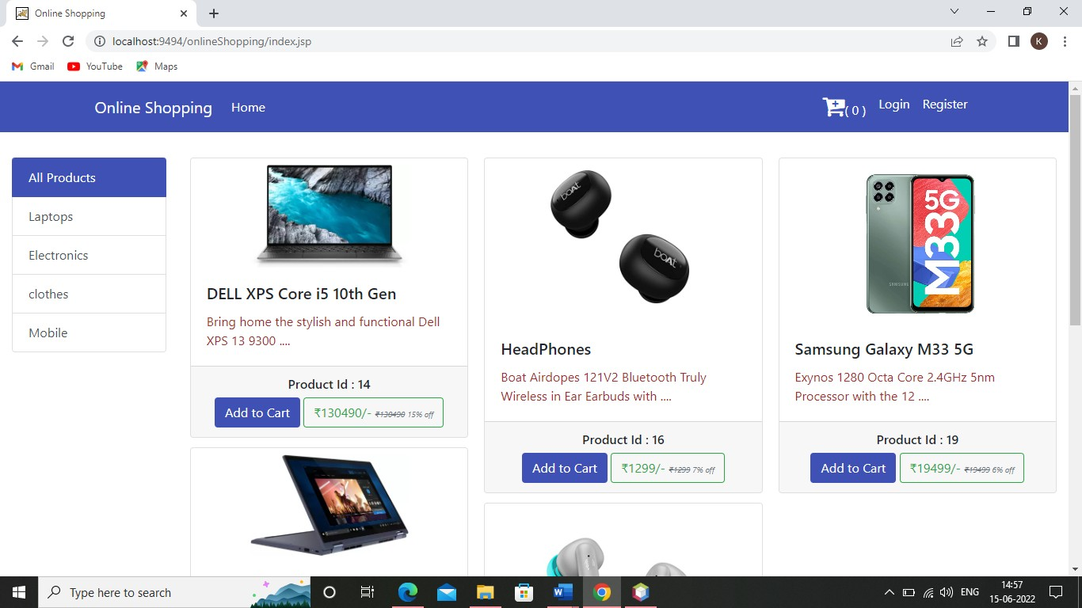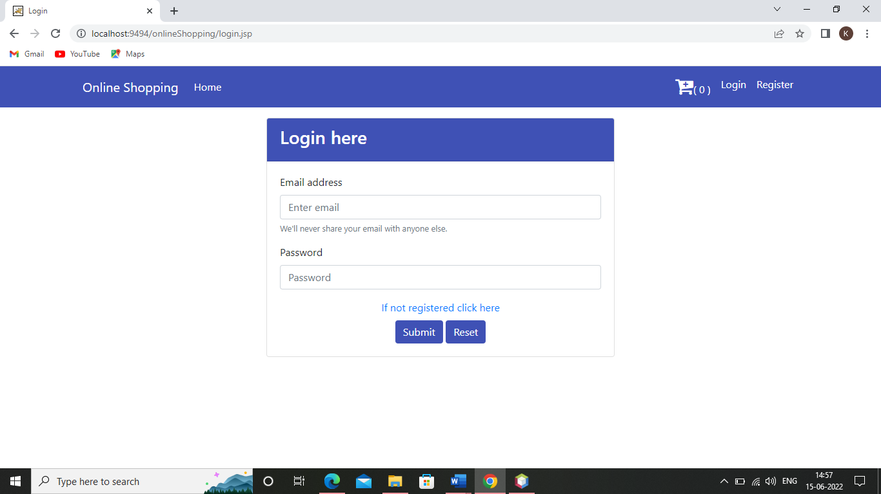

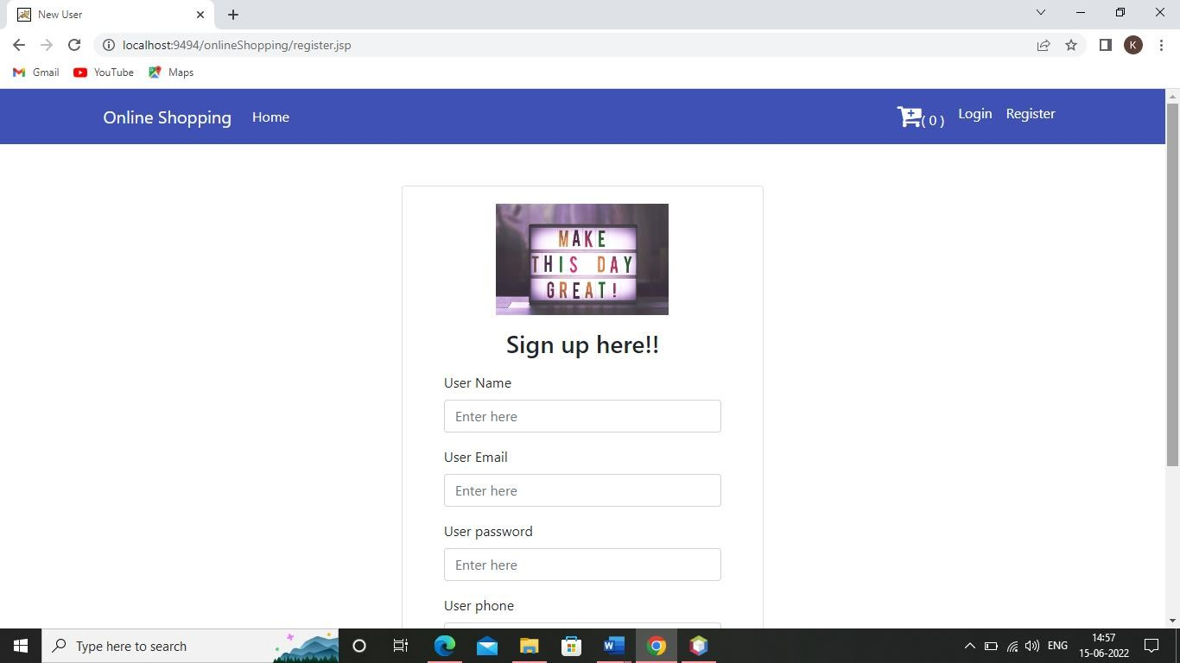

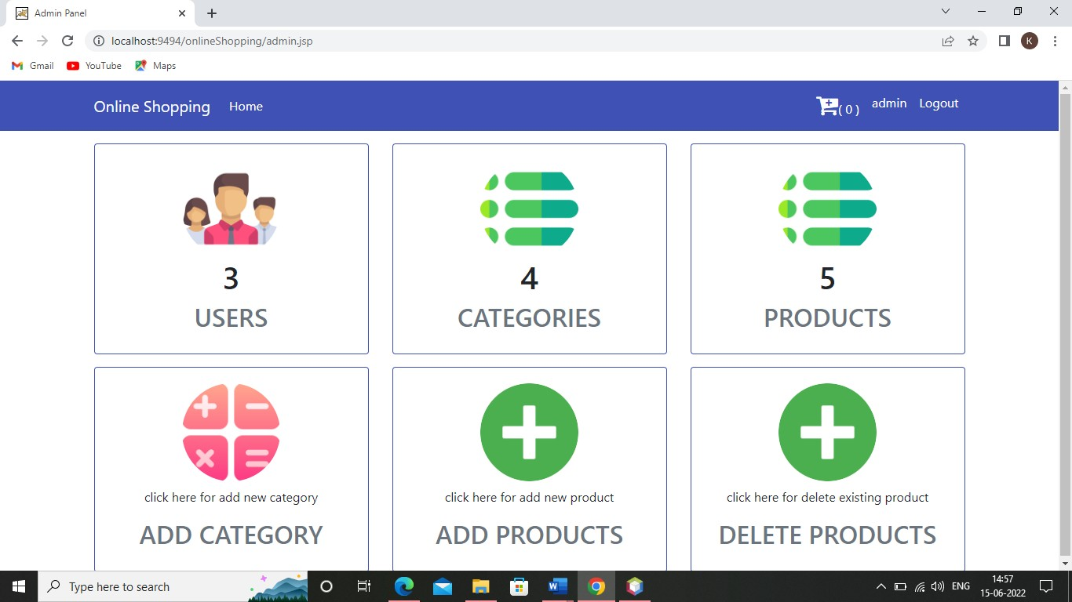

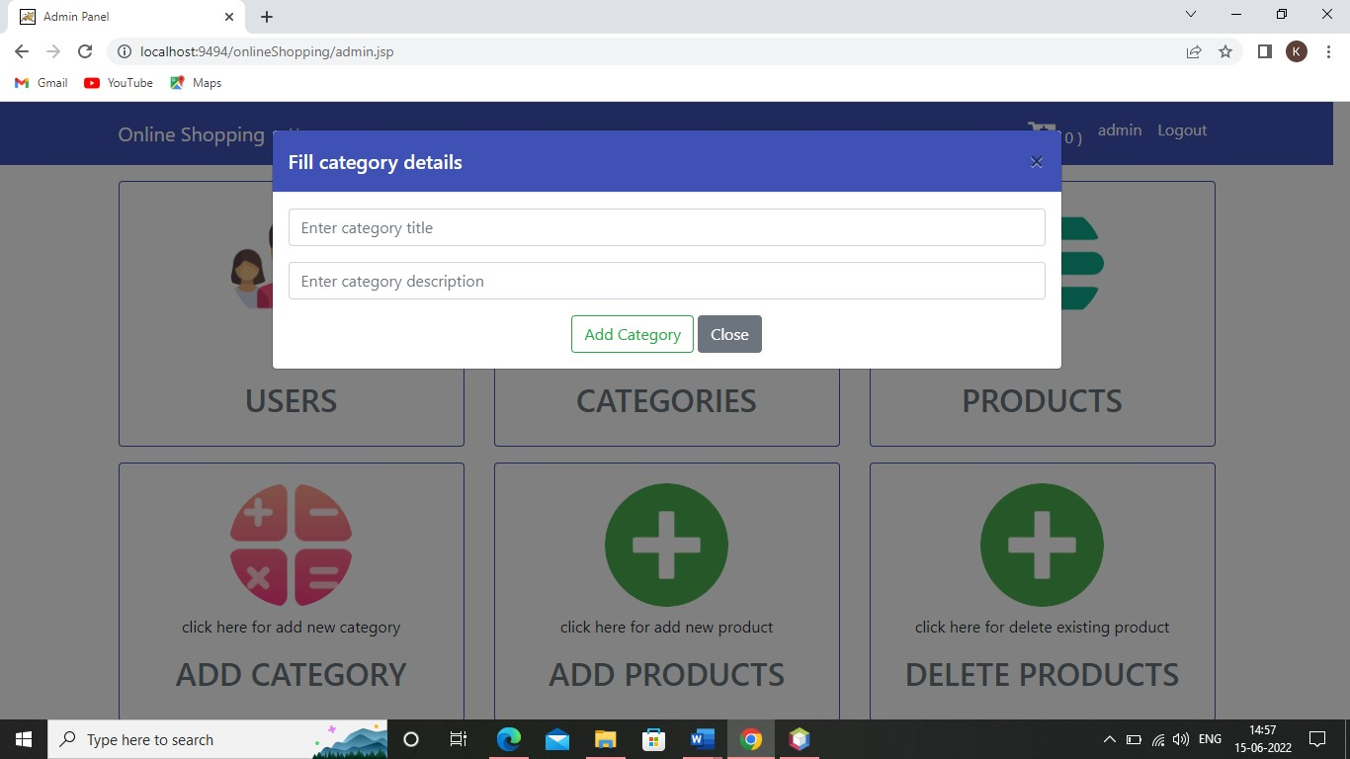

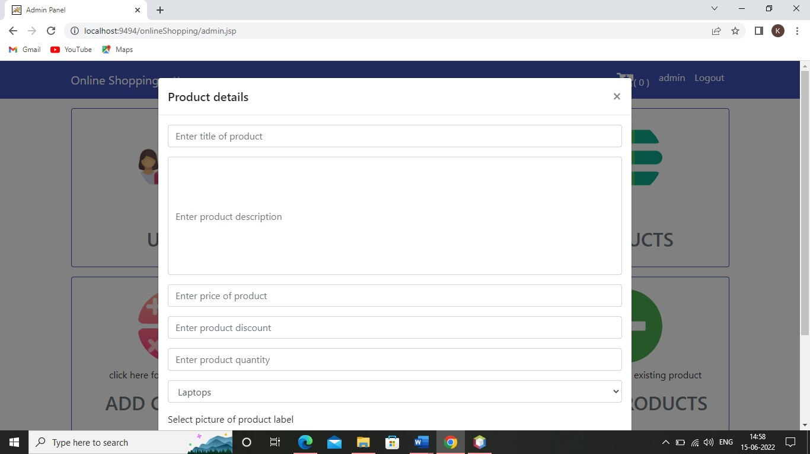

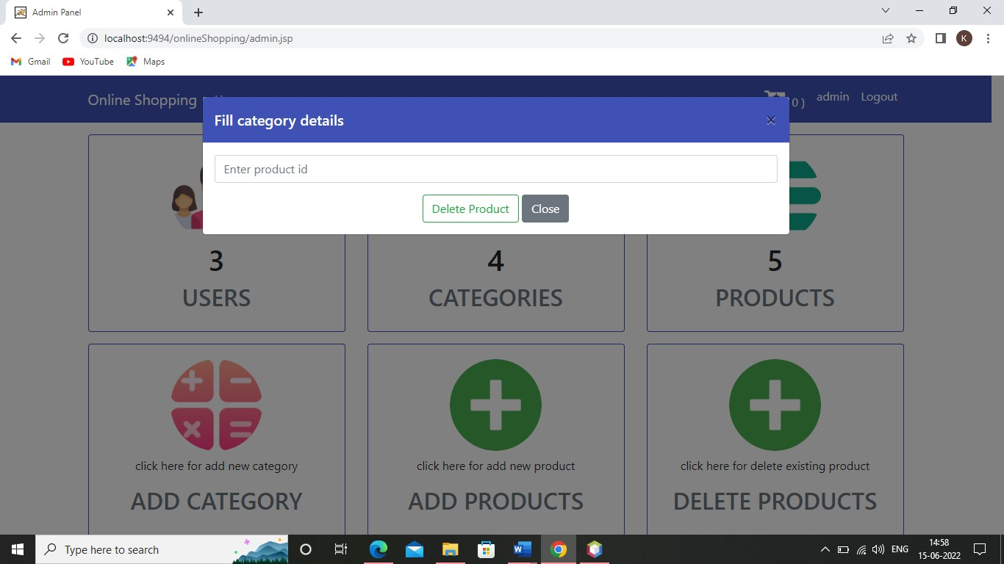

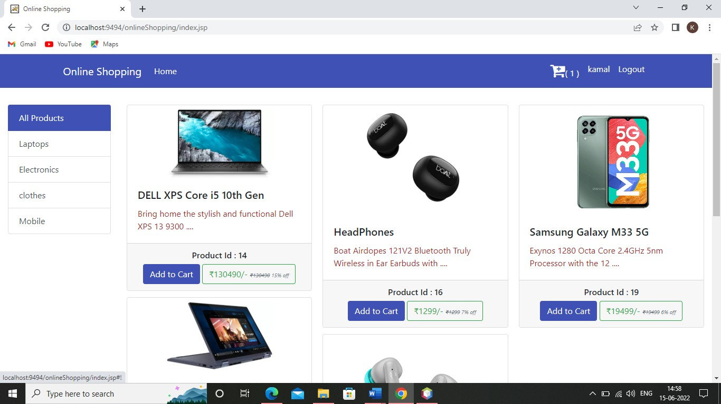

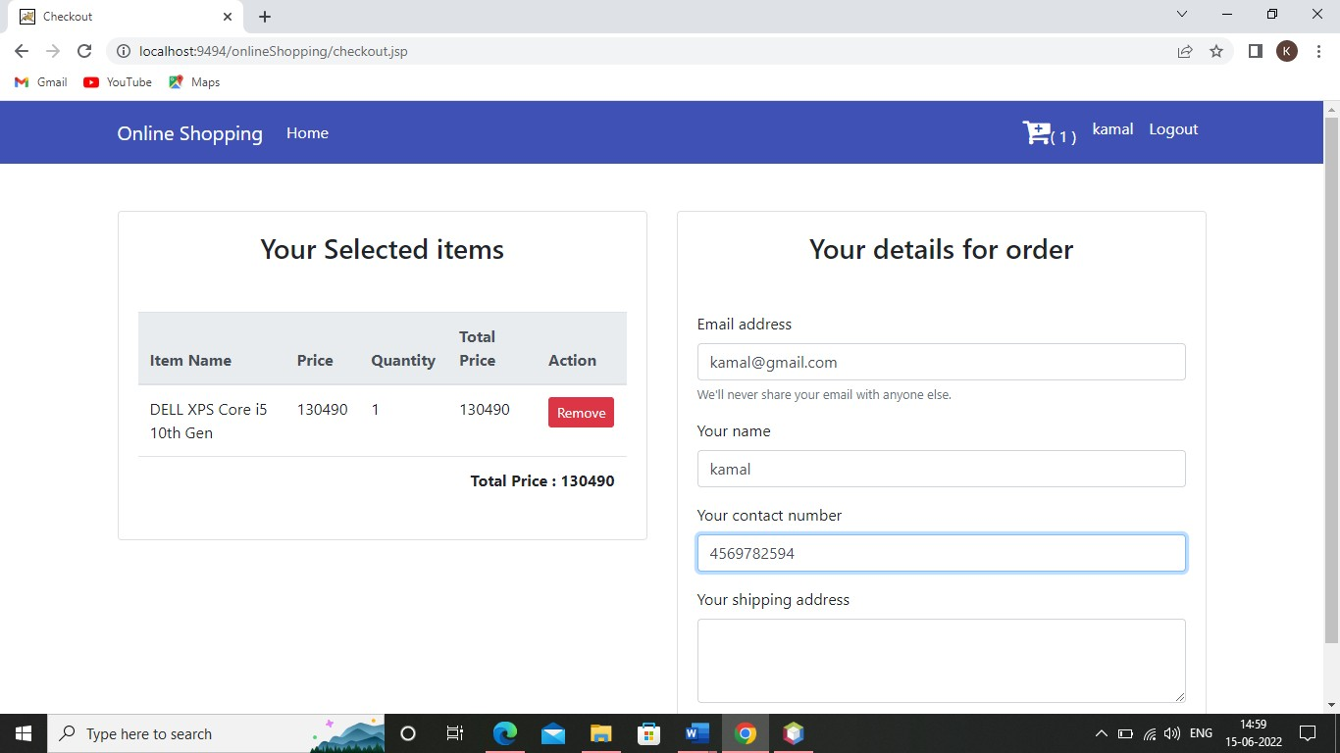

1. **Conclusion**

The project entitled Online shopping system was completed successfully. The system has been developed with much care and free of errors and at the same time it is efficient and less time consuming. The purpose of this project was to develop a web application and an android application for purchasing items from a shop. This project helped us in gaining valuable information and practical knowledge on several topics like designing web pages using html & css, usage of responsive templates, designing of android applications, and management of database using mysql . The entire system is secured. Also the project helped us understanding about the development phases of a project and software development life cycle. We learned how to test different features of a project. This project has given us great satisfaction in having designed an application which can be implemented to any nearby shops or branded shops selling various kinds of products by simple modifications. There is a scope for further development in our project to a great extend. A number of features can be added to this system in future like providing moderator more control over products so that each moderator can maintain their own products. Another feature we wished to implement was providing classes for customers so that different offers can be given to each class. System may keep track of history of purchases of each customer and provide suggestions based on their history. These features could have implemented unless the time did not limited us.

## Bibliography

* + **<https://www.javatpoint.com/jsp-tutorial>**
  + **<https://www.javatpoint.com/servlet-tutorial>**
  + **<https://www.javatpoint.com/hibernate-tutorial>**
  + **<https://www.w3schools.com/js/>**